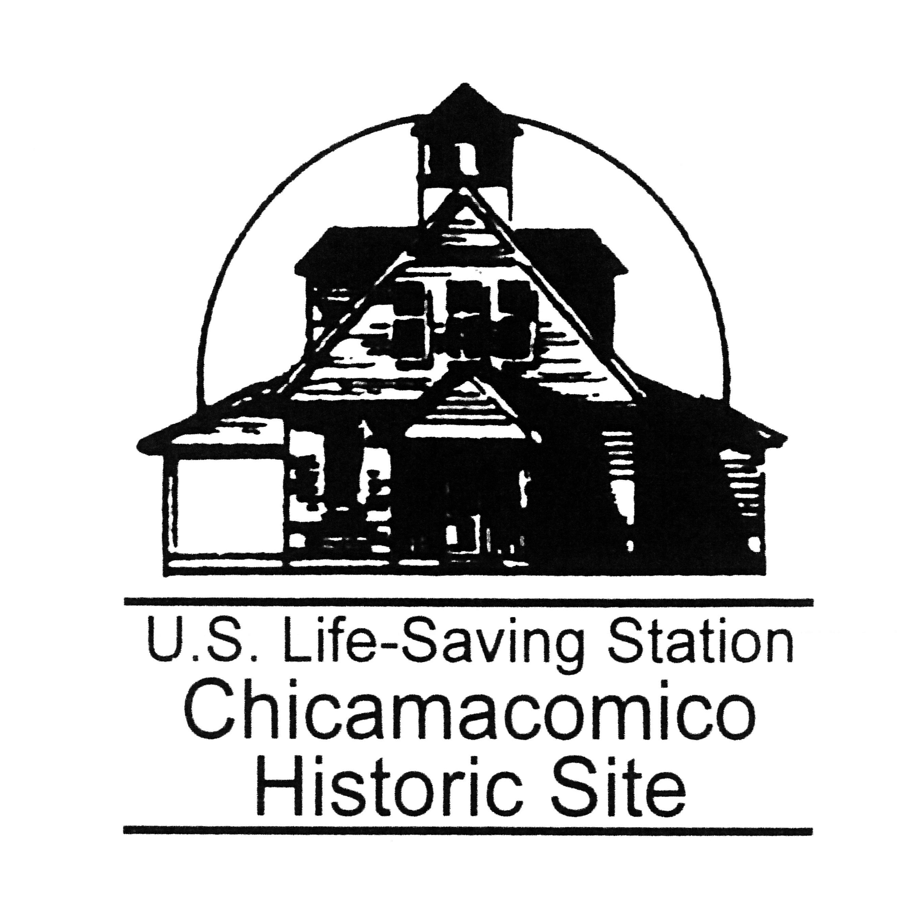
Chicamacomico Historical Association Membership Form

Why become a member of the Chicamacomico Historical Association?
- Memberships include the satisfaction of knowing you have helped preserve this incredible piece of American history.
- Memberships include quarterly newsletters to keep you updated on restoration and other projects, invitations to special events
- Support educational programming at the station.
- Members are requested to identify themselves when they are visiting the Chicamacomico Historic Site.
- Memberships allow use of the facilities for special occasions at a reduced rate.
- Memberships are tax-deductible.
- Membership renewal courtesy notices will be e-mailed to you automatically each year, and are generally due by April 1st. Thank you for your membership!
MEMBERSHIP AT EVERY LEVEL OF GIVING
Rescuer $25
Life-Saver $50
Surfman $100
Station Keeper $250
Hero $500
To become a member, complete below and mail check to:

Chicamacomico Historical Association
P.O. Box 5
Rodanthe, NC 27968-0005

NAME: _____________________________________________________________
ADDRESS: __________________________________________________________
CITY: __________________________________ STATE: ______ ZIP: ____________
PHONE: ____________________ CELL PHONE: ____________________________
EMAIL: _____________________________________________________________
Your contributions to the Chicamacomico Historical Association, a 501(c)(3) nonprofit organization is tax deductible. The Chicamacomico Historical Association does not provide any goods or services to you in consideration of your contribution. Our tax ID number is 23-7441279.

